Assessment Schedule – 2014
Physics: Demonstrate understanding of electrical systems (91526)
Assessment Criteria
Achievement | Achievement with Merit | Achievement with Excellence
Demonstrate understanding requires writing statements that typically show an awareness of how simple facets of phenomena, concepts or principles relate to a described situation. For mathematical solutions, relevant concepts will be transparent, methods will be straightforward. | Demonstrate in-depth understanding requires writing statements that typically give reasons why phenomena, concepts or principles relate to given situations. For mathematical solutions, the information may not be directly useable or immediately obvious. | Demonstrate comprehensive understanding requires writing statements that typically give reasons why phenomena, concepts or principles relate to given situations. Statements will demonstrate understanding of connections between concepts.

Grade allocation for all Questions
No | N1 | N2 | A3 | A4 | M5 | M6 | E7 | E8
na | 1a | 2a  1m | 3a  1m 1a  1e | 4a  2m  1e 1a | 1m 3a  1e 1m  1e 2a | 2m 2a  1e 1m  1e 3a | 1e 1m 2a  1e 2m  1e 4a | 1e 2m 1a  1e 1m 3a  1e 2m 1a  2e 1m (or 2a)

Q | Evidence | Achievement | Merit | Excellence
ONE  (a)(i) | 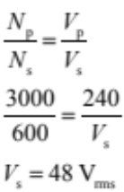 | - 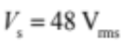
(ii) | 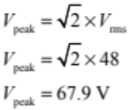 | - V_{peak} = 67.89 V  - 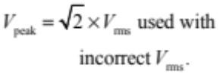
(b) | The rms voltage is the root mean squared voltage. The rms is a kind of average voltage used because the average of a sin function over time is zero. The rms voltage has the same magnitude as the DC voltage that would deliver the same power output as the AC voltage being described. | - The rms is a kind of average voltage, used because the average voltage is zero because the voltage varies / sin wave.  - The rms voltage has the same magnitude as the DC voltage that would deliver the same power output as the AC voltage being described.  - Sketch showing AC voltage, average V and V_{rms}.  - Peak values reached for a short time only because of sin curve / V increasing and decreasing (it is the average V is wrong).
(c) | 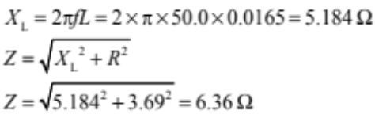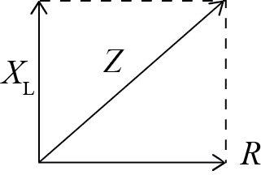 | - X_{L}= 5.2 Ω.  - Correct method of calculating Z using incorrect reactance.  - Correct phasor.  - No phasor but correct explanation. | - Correct phasor diagram drawn with correct explanation.  - Z = 6.36 Ω.
(d) | 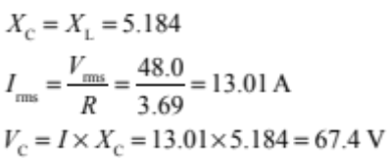 | - X_{C} = X_{L}  - V_{C} = V_{L}  - Z = R  - Calculated f₀ and then X_{C} (X_{L} correct in 1c). | - 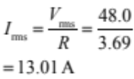  - Calculated f₀ and then X_{C} (X_{L} not calculated in 1c) | - 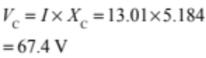

Q | Evidence | Achievement | Merit | Excellence
TWO  (a) | 11.0 – 10.0 − 2.5I – 20I − 5.0I − 2.7I = 0  1.0 – 30.2I = 0  I = 0.03311 = 0.033 A | - Kirchhoff equation attempted.  - Total resistance is 30.2 Ω.  - Total PD is 1.0 V. | - Complete correct working (ignore negative value).
(b) | The current will flow right to left (anticlockwise), because the +ve terminal of the 11 V battery is at a higher potential than the +ve terminal of the 10V battery, and current flows from high potential to lower potential.  OR  The current will flow right to left (anticlockwise), because, when a Kirchhoff equation is constructed with the current flowing in this direction, the value of the current is positive. | - Right to left / anticlockwise because the top battery has a higher potential difference.  - Right to left/ anticlockwise because positive calculated value is produced when clockwise current is used.
(c) | If I₁ is the current through switch 1, I₂ the current through switch 2, and I₃ the current through switch 3:  I₃ = I₁ + I ₂  11.0 – 5.0I₁ – 2.7I₁ = 0 ⇒ I₁ = 1.4286  10.0 – 20I₂ – 2.5 I₂ = 0 ⇒ I₂ = 0.4444  ⇒ I₃ = 1.873 = 1.87 A | - I₁ = 1.4286 A  - I₂ = 0.4444 A  - I₁+I₂=I₃ (S₁+S₂=S₃) | - I₁ and I₂ correctly calculated and added.
(d) | The emf of the battery will stay the same, but the internal resistance will increase.  The resistance of branch 2 will increase, so the current will decrease. As the current through the  20.0 Ω resistor decreases, the voltage through the resistor will decrease. The power delivered to the resistor will drop because of the drop in voltage and current. | - The emf of the battery will stay the same.  - The current will decrease.  - Lost volts increases.  - Output Voltage decreases.  - Power decreases.  - Attempt at calculating change in P/ Vo/ I | - Power will decrease, because current and output voltage will decrease.  - Power decreases because output voltage/ current decreases but emf constant.  - Power decreases because lost volts increases.  - Calculation using P = I²R, no mention about emf or V₀  - Output P decreases because more power is used by internal resistance. | - A decrease in power will occur because current and voltage will decrease, because the resistance of branch 2 has increased, while the emf has stayed the same.  - Correct calculations comparing before and after.

Q | Evidence | Achievement | Merit | Excellence
THREE  (a) | - The potential of the +ve terminal of the battery is higher than the capacitor plate it is connected to, and the –ve terminal is at a lower potential than the plate it is connected to.  - Charge flows from high to low, so electrons will move from the negative terminal on to the plate, and from the plate on to the positive terminal.  - Charge will flow until there is no potential difference between each plate and the terminal it is connected to. This happens when the voltage across the capacitor plates is equal to the voltage of the battery. | - Indication that the current will become zero only when the voltages in the circuit are equal and opposite.  - Voltage of battery is greater than voltage of capacitor therefore voltage of capacitor increases.  - Parallel components have same voltages.  - Current / charges flow from battery onto capacitor.  - It is gaining / storing energy.  - It is fully charged. | - Because the plates are charged, they will have a potential difference, which will increase until it matches the voltage of the battery.  - Because they are in parallel and voltage across resistor is zero.  - Kirchhoff’s law explanation.  - Q = CV, as the capacitor charges, Q increases, therefore V increases.
(b) | E_{P} = ½QV = 0.5 × 8.6 × 10⁻³ × 12  = 0.0516 = 0.052 J | - 0.052 J
(c) | 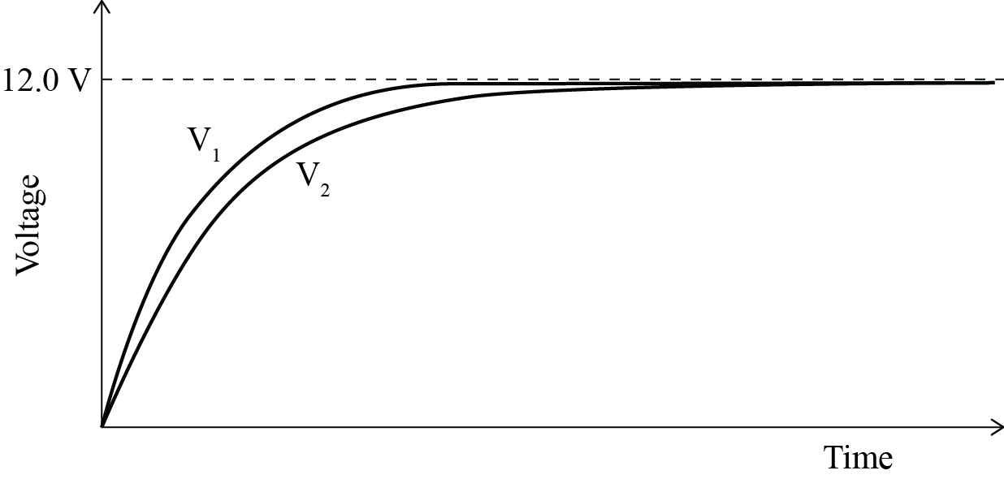 | - Correct shape.
(d) | - As soon as current starts to change from its original zero value, current, and hence flux, in the inductor is changing. Changing flux in an inductor induces a voltage, which will act to oppose the change that is making it. | - The inductor slows / opposes the change in current.  (not “decreases the current”).  - A voltage is induced to oppose the changing current.  - Voltage induced due to changing flux/ magnetic field. | - Changing current linked to changing flux, causing a voltage that opposes the changing current.  - Takes longer for current to decrease because induced voltage opposes the change.  - Opposing voltage induced due to rate of change of current. | Changing current linked to changing flux, causing a voltage that opposes the changing current therefore the current takes longer to decrease.
(e) | - When the capacitor is fully charged, energy is stored in its electric field (E = ½QV).  - When the capacitor is fully charged, the current is zero, so no energy is stored by the inductor  (E = ½LI²).  - When the capacitor discharges, Q goes down, so less energy is stored.  - While the capacitor is discharging, there is increasing current in the circuit, so energy is stored by the inductor.  - The energy stored by the inductor comes from the energy lost by the capacitor. | - A capacitor stores energy in an electric field.  - An inductor stores energy in a magnetic field.  - Energy of capacitor decreases and energy of inductor increases.  - When the capacitor is fully charged, the current is zero, so no energy is stored by the inductor.  - When the capacitor discharges, V / Q goes down, so less energy is stored.  - While the capacitor is discharging, there is increasing current in the circuit, so energy is stored by the inductor.  - Energy of inductor increases because current in the circuit increases. | - Energy (in the electric field) of the capacitor is decreasing because energy depends on charge / V, and charge / V is decreasing.  - Energy (in the magnetic field) of the inductor is increasing because energy depends on current, and current is increasing.  - Energy is transferred from the electric field of the capacitor to the magnetic field of the inductor. | - Full explanation linking the rate of drop in energy stored in electric field of capacitor to rise in energy stored in magnetic field of inductor.  OR  - Energy (in the electric field) of the capacitor is decreasing because energy depends on charge / V, and charge / V is decreasing.  AND  Energy (in the magnetic field) of the inductor is increasing because energy depends on current, and current is increasing.

Cut Scores
 | Not Achieved | Achievement | Achievement with Merit | Achievement with Excellence
Score range | 0 – 6 | 7 – 13 | 14 – 18 | 19 – 24

